Case Study: UPI / Online Payment Fraud
Case Study: UPI / Online Payment Fraud
UPI (Unified Payments Interface) fraud is a common cybercrime where attackers trick users into transferring money or revealing sensitive banking details. This type of fraud has increased rapidly with the rise of digital payments in India.
A typical case involves a fraudster contacting the victim via phone, SMS, or messaging apps. Step 1: The scammer pretends to be a bank official, customer support agent, or even a buyer/seller from an online marketplace. Step 2: They create urgency by claiming an issue such as a blocked account, refund processing, or payment request. Step 3: The victim is asked to click on a malicious link or approve a “collect request” on their UPI app. Step 4: The victim unknowingly authorizes the transaction by entering their UPI PIN, believing they are receiving money instead of sending it. Step 5: The money is instantly transferred to the scammer’s account and becomes difficult to recover.
These scams usually target students, elderly people, and individuals unfamiliar with digital payment systems. People who frequently use online marketplaces are also at higher risk.
The consequences can be severe, including financial loss, emotional stress, and loss of trust in digital systems. Victims often face difficulty recovering funds due to the speed of transactions.
This case highlights the importance of awareness—users should never share their UPI PIN, click unknown links, or approve unexpected payment requests.
Real incident
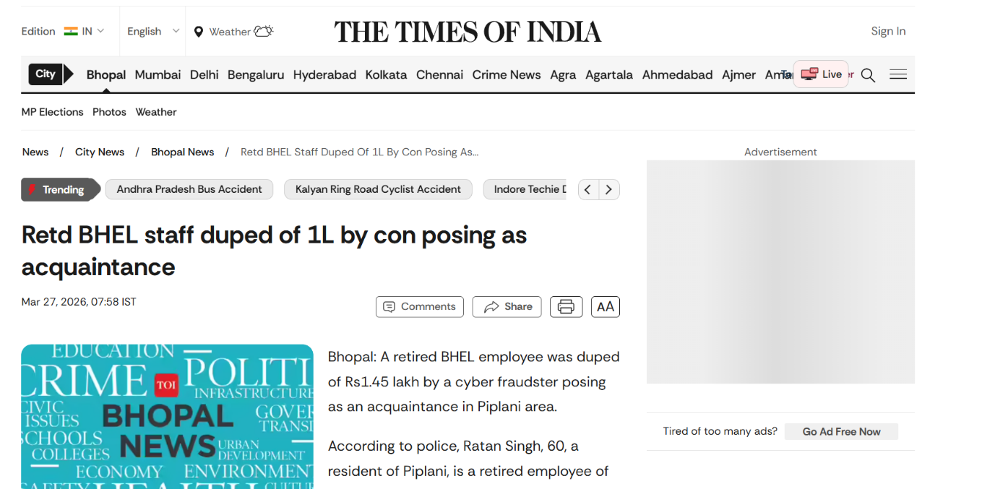
A real incident of UPI fraud was reported in Bhopal, where a retired BHEL employee lost ₹1.45 lakh to a cybercriminal posing as an acquaintance.
In this case, the fraudster contacted the victim through an unknown mobile number and imitated the voice of someone familiar to gain trust. Step 1: The scammer established credibility by pretending to be a known person. Step 2: During the conversation, he manipulated the victim into believing there was an urgent financial need. Step 3: The victim was asked to share sensitive UPI-related details or perform transactions. Step 4: Trusting the caller, the victim transferred money in two installments. Step 5: Once the payment was completed, the scammer disappeared, and the victim realized the deception.
Such scams typically target elderly individuals or those less familiar with digital fraud techniques. Attackers rely heavily on social engineering—building trust and creating urgency—to bypass rational thinking.
The consequences include immediate financial loss and emotional distress. Recovery of funds is often difficult due to the speed of UPI transactions. Victims must report quickly to authorities, such as the national cybercrime helpline, to increase chances of recovery.
This case highlights the importance of verifying identities before making digital payments and never sharing sensitive banking information over calls.

